1: E-commerce Platform Search Function
SearchTest.java
package EcommerceSearchFunction;
import java.util.Arrays;
import java.util.Scanner;
public class SearchTest {
// Linear Search - O(n)
public static int linearSearch(int[] ids, int target) {
for (int i = 0; i < ids.length; i++) {
if (ids[i] == target) {
return i;
}
}
return -1;
}
// Binary Search - O(log n), requires sorted array
public static int binarySearch(int[] ids, int target) {
int low = 0, high = ids.length - 1;
while (low <= high) {
int mid = low + (high - low) / 2;
if (ids[mid] == target) {
return mid;
} else if (ids[mid] < target) {
low = mid + 1;
} else {
high = mid - 1;
}
}
return -1;
}
public static void main(String[] args) {
Scanner scanner = new Scanner(System.in);
System.out.print("Enter number of products: ");
int n = scanner.nextInt();
int[] productIds = new int[n];
System.out.println("Enter " + n + " product IDs:");
for (int i = 0; i < n; i++) {
productIds[i] = scanner.nextInt();
}
System.out.print("Enter product ID to search for: ");
int targetId = scanner.nextInt();
// Linear search on original (unsorted) order
int linearIndex = linearSearch(productIds, targetId);
// Binary search needs a sorted copy
int[] sortedIds = Arrays.copyOf(productIds, productIds.length);
Arrays.sort(sortedIds);
int binaryIndex = binarySearch(sortedIds, targetId);
System.out.println();
if (linearIndex != -1) {
System.out.println("Linear Search: Found at index " + linearIndex);
} else {
System.out.println("Linear Search: Not Found");
}
if (binaryIndex != -1) {
System.out.println("Binary Search: Found at index " + binaryIndex + " (in sorted array)");
} else {
System.out.println("Binary Search: Not Found");
}
scanner.close();
}
}

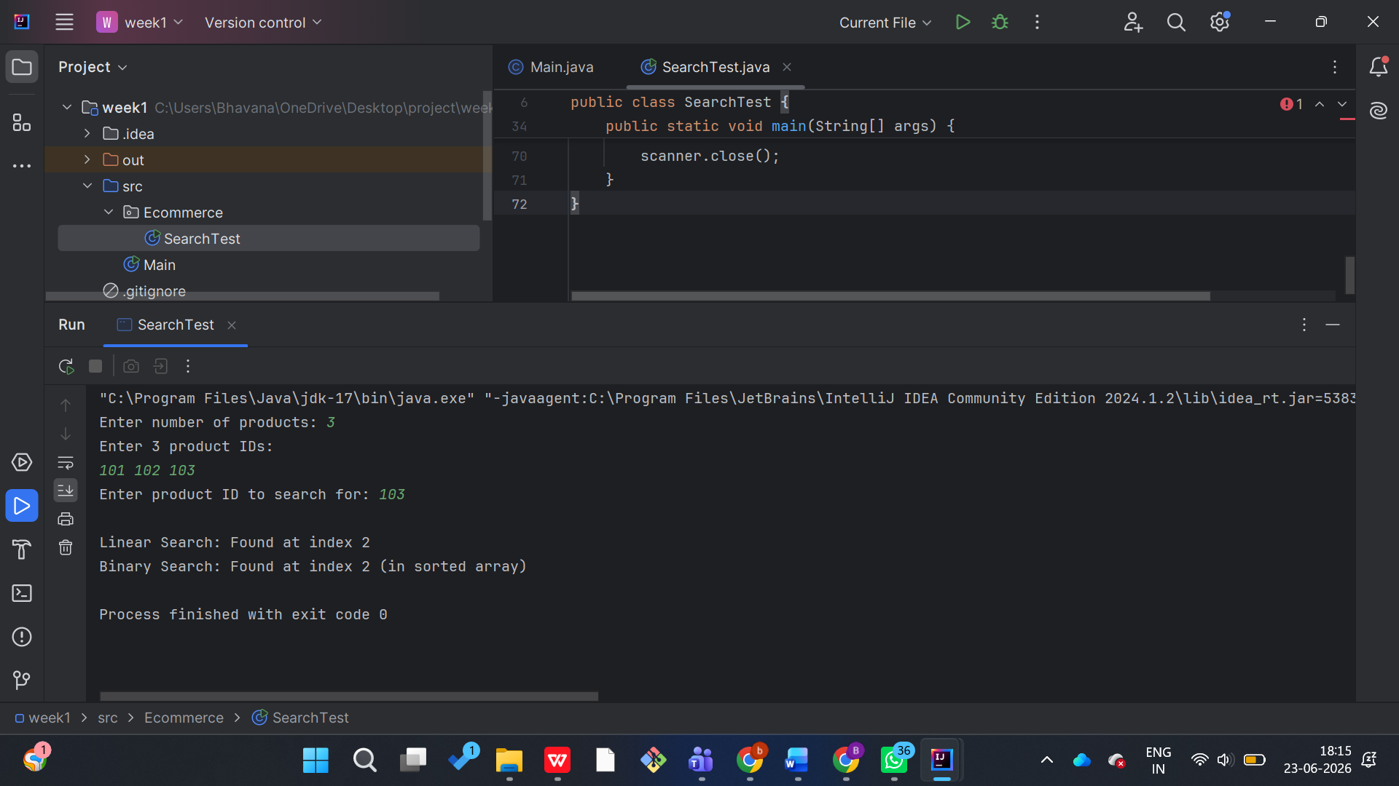

2: Financial Forecasting
ForecastTest.java
package FinancialForecastingExample;
import java.util.Scanner;
public class ForecastTest {
// Recursive approach
// FV(n) = FV(n-1) * (1 + growthRate), base case FV(0) = presentValue
public static double calculateFutureValue(double presentValue, double growthRate, int periods) {
if (periods == 0) {
return presentValue;
}
return calculateFutureValue(presentValue * (1 + growthRate), growthRate, periods - 1);
}
public static void main(String[] args) {
Scanner scanner = new Scanner(System.in);
System.out.print("Enter present value: ");
double presentValue = scanner.nextDouble();
System.out.print("Enter annual growth rate (%): ");
double growthRatePercent = scanner.nextDouble();
double growthRate = growthRatePercent / 100.0;
System.out.print("Enter number of years: ");
int periods = scanner.nextInt();
double futureValue = calculateFutureValue(presentValue, growthRate, periods);
System.out.printf("%nFuture Value after %d years: $%.2f%n", periods, futureValue);
scanner.close();
}
}

